**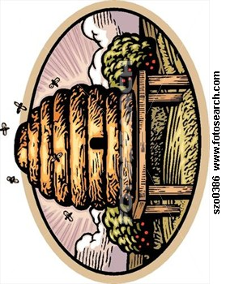Upcoming dates of interest for November:**

1st-Wednesday 7pm Choir Practice

2nd-Thursday 11:30am 60+ @ LPC

5th-Sunday 8am Trustee Mtg

6th-9th-Mon-Thurs 6pm Dress Rehearsal

7th-Tuesday all dayy Election Day

10th-11th-Friday & Saturday Dinner Theater

13th-Monday 12pm Old Timer’s

14th-Tuesday 6pm Lions Club

15th-Wednesday 7pm Choir Practice

17th-18th-Friday & Saturday Dinner Theater

19th-Sunday 12-6pm Fellowship hall reserved

21st-Tuesday 6pm Cub Scouts

22nd-Wednesday Choir Practice

23rd-Thursday Happy Thanksgiving

28th-Tuesday 6pm Lions Club

29th-Wednesday 7pm Choir Practice

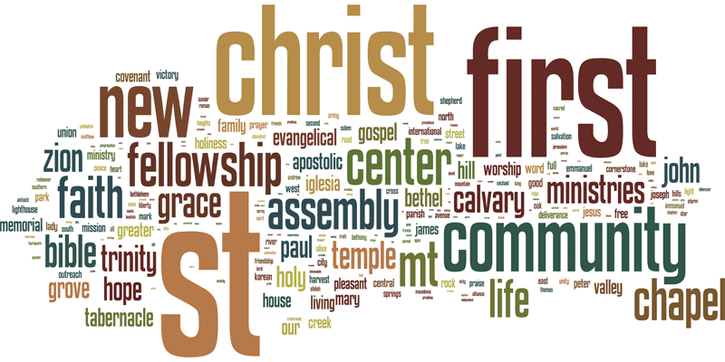



Pat Ayers – South Africa



1st George Horchler 20th Stacey Booth

Barb Como 21st Ryan Rynd

Didge Lutton 22nd Sonny Mathieson

5th Leroy Grimm 23rd James Schepp

8th Melanie Riemer Liam Weller

9th Annette Mershimer 27TH Emily Smith

16th Katie Wilson Jennifer Collins

18th Michael Collins 30th Dick Patterson

19th Martha Shaw 31st Rick Martin



2nd Pat & Prugh Barger 1965

4th Jim & Kathy Schepp 1974

7th James & Nikki Schepp 2006

11th Ken & Judy Brown 1969

18th Bob & Missy Orr 1997

20th Ron & Ruth Bice 1979

Just a small reminder about what we are striving towards and the ECO mission as we approach the ECO Fall Gathering to be held on October 6th & 7th at Meridian Church in Butler:

AN ECO MOMENT: Remember that the mission of ECO is simple. The Covenant Order of Evangelical Presbyterians (ECO) seeks to build flourishing churches that make disciples of Jesus Christ. Simple and Profound! Toward that end we share the simple and profound, an excerpt from a presentation by Dana Allin, ECO Synod Executive, wherein he discusses the basic standards for ordination.

“My initial involvement in ECO was as part of the team that was developing ECO’s polity. When the team began looking at the part of the polity that would address standard for ordination, there was a very rich discussion. All of us were in agreement that we wanted to set a high bar on the quality of person whom we were launching into pastoral leadership. At the same time, we wanted to live into our value of Leadership Velocity. It was actually Rich Mouw, former President of Fuller Seminary, who encouraged us not to require the Master of Divinity degree for ordination. He saw too many stellar candidates who, because of a variety of responsibilities in their lives and ministries, did not complete an M.Div, and thus did not pursue ordination in mainline denominations.

I think over time we have often assumed that we can simply delegate the role of training pastors to other institutions. We have assumed that if someone has a degree, then he or she is ready for ministry. While seminaries can do a phenomenal job at developing certain characteristics in leaders, we need to take more responsibility in assuring that our pastors have the totality of qualities and characteristics needed for ministry.

So, ECO has developed a list of core leadership competencies. These competencies include areas of ‘head, heart, and hands’. Head, heart, and hands means that there is certain knowledge that a person must have (head). There should also be a level of spiritual maturity (heart), and proficiency in skills that are needed for ministry (hands). ….”

Simple and profound!

**Our Veterans Appreciation Luncheon**

will be held on Saturday, October 21 at noon.

If you have a friend you would like to have join us, please see Tracy or Phyllis so we can send and invitation and information.

**Missing Man Table and Honors Ceremony**

As you entered the room, you may have noticed a special table; it is reserved to honor our missing men.

Set for six, the empty chairs represent Americans who were or are missing from each of the services – Army, Marine Corps, Navy, Air Force, and Coast Guard – and civilians, all with us in spirit.

Some here were very young, or not yet born, when the Vietnam War began; however, all Americans should never forget the brave men and women who answered our Nation’s call and served the cause of freedom in a special way.

Let me explain the meaning of this table, and then join me for a moment of silent prayer.

The table is round – to show our everlasting concern.

The cloth is white – symbolizing the purity of their motives when answering the call to serve.

The single red rose reminds us of the lives of these Americans….and their loved ones and friends who keep the faith, while seeking answers.

The red ribbon symbolizes our continued determination to account for them.

A slice of lemon reminds us of their bitter fate, captured and missing in a foreign land.

A pinch of salt symbolizes the tears of our missing and their families – who long for answers after decades of uncertainty.

The lighted candle reflects our hope for their return – alive or dead.

The Bible represents the strength gained through faith to sustain us and those lost from our country, founded as one nation under God.

The glass is inverted – to symbolize their inability to share a toast.

The chairs are empty – they are missing……….. (moment of silence)

MC900048861[1] **HAM DINNER**

Volant Lion’s Club will hold its annual Ham Dinner on **Thursday, October 19th**

From 4 – 7 p.m. at Leesburg Church.

Adults - $8.00 Children 12 & under - $4.00

Menu: Ham Scalloped Potatoes Cole Slaw

Applesauce Rolls – Beverage Pie or Cake

**The winter months will soon be upon us – can you help by donating hats, gloves, scarves, even your “gently” warn winter jacket for our school children? Non-perishable food & household items are also needed. Place them in the grocery cart just inside the entrance door. Thank you!**

Year to Date

Expenses: $133683.34

Income: $118611.96

 **$-15071.38**

August

Expenses $57709.57

Income $17040.05

**$-40669.72**



Greg Kingsley

http://download.churchart.com/ArtLineLibrary/u/us/usher6c.gif

Tom & Stacey Booth



6th Charlotte Yeager & Margaret Ifft

13th Jim & Kathy Schepp

20th Pat & Prugh Barger

27th Gordon Hensel & Bob Frisk

blood pressure_1854_50

8th & 22nd – Liz Kingsley

HELP! Here is a list of volunteers for September…..

 ****

**Date Liturgist Greeter Nursery Prayer Leader**

1st Amelia Weller Jack Riley \*\* Travis Weller

8th Nathan Collins Kathy McConnell Madi J Kathy Schepp

15th Pete Grimm Jake Lowry \*\* Maryann Collins

22nd Sophia Martin Rick Martin Madi J Kathy Schepp

29th Gabby Collins Tom Booth \*\* Jenn Collins

\*\* The nursery is still in need of volunteers for most Sundays. If you are willing to assist, please contact the church office or Liz Kingsley

****

**Emmaus Retreat is coming up:**

Men’s Walk: Oct 12th–Oct 15th

Women Walk: Oct 19th-Oct 22nd

Contact the church office for more information

**Prayer Families:**

Oct 1-7:

Ned and Agnes Curfman, 2143 Potter Run Rd., Volant 16156

Marian Dambach, 297 Chapel Drive, Ellwood City 16117

Oct 8-14:

Missy Davies, 1590 Shaw Rd., Volant 16156

Lane Dess, 145 Coal Hill Ln., Slippery Rock 16057

Oct 15-21:

Rick & Kathy Dillaman, 1695 S. Center St. Ext., Grove City 16127

Sally Duncan, 1301 W. Liberty Rd., Slippery Rock 16057

Oct 22-28:

Pete Ellis, 205 ½ N. Shenango St., Mercer 16137

Warren & Karen Enscoe, 2136 Perry Hwy., Portersville 16051

Oct 29-Nov 4:

Helen Eshelman, 69 Smith Rd., Volant 16156

Ben & Jamie Filer, 6006 Hazelnut Dr., Dover, DE 19901

* "Each man should give what he has decided in his heart to give, not reluctantly or under compulsion, for God loves a cheerful giver."* 2 Cor 9:7

ANNUAL PIE AUCTION—Sunday October 1st following worship and a potluck luncheon!! Please plan to come and enjoy a delicious lunch and then the fun, festivities and fellowship with our annual pie auction to benefit the Veterans Lunch, Touch A Truck and other missions of the Mission Shaped Church Committee!!

Plans for our Veterans Appreciation Dinner are underway for a spectacular time on **Saturday, October 21** (beginning at noon). We need your help in finding veterans we may have missed in the  past years. If you think of a friend, neighbor or family member, please contact the church office or Phyllis.



SENIOR CE planning meeting on Saturday, October 7, 2017 at 6pm. Lasagna dinner provided. Will plan youth activities as well as go over San Diego information that we currently have available. All who would like to have input with the youth group are welcome. Please text or call Connie with your RSVP so that dinner can be planned, 724-307-2819

Grove City Area Historical Society presents the following events as part of its “Fall Speaker Series”.   All events are free, open to the public, and held at the Grove City Area Historical Society Building, 111 College Ave., Grove City, PA.  Should anyone wish further information, they may call 724-533-4464.

**Monday, Oct. 9, 2017,** 6:30 p.m. Mary Jo Palmer presents “The Rhona Disaster:  A World War II Tragedy”.  A guarded government secret for many years, the World War II tragedy of the HMS Rhona is being presented by the daughter of Grove City resident and Rhona disaster survivor, Frank Bryer.

**Monday, Oct. 23, 2017**, 6:30 p.m. Laurie McCandless presents “Celebrate Family History Month”.  Laurie will introduce us to five generations of her ancestors who made their home in Hickory Township, Mercer County.  She will also share some interesting ties to Grove City.

**Coolspring Corn Maze Praise Night**

The first Coolspring Corn Maze Praise Night will be on the evening of October 7thbeginning at 7:30 PM.  A live outdoor concert featuring contemporary worship artist Jordan Biel and band, Christian Rap Artist G.I.L. (God Is Love), and Damon Covert will be performing and lifting up our God in praise.  Everyone is welcome, rain or shine, come early for under roof seating.  The concert is free with admission to the maze.  For more info go to [**http://www.coolspringmaze.com**](http://www.coolspringmaze.com/).

**Annual Basket Raffle**

ShenangoOnTheGreen will be holding their annual Basket Raffle on October 14th from 8:30 – 2:00 PM.  Tickets can be purchased from October 9th-13th (8:30 AM – 6:30 PM).  All proceeds to benefit the SeniorCARE Fund, providing support for your local seniors.  For more information, visit [**www.shenangosrcare.org**](http://www.shenangosrcare.org/) or call Shawna Bostaph at 724-946-3402.



ABOUT I AM THEY

I AM THEY made its national debut in January 2015 with their self titled album on Essential Records. The band’s five-piece, pop-acoustic worship sound is anchored by three-part vocal harmonies. The group, made up of Abbie Parker (vocals/harmonium), Jon McConnell (vocals/guitar/keys), Matt Hein (vocals/guitar/mandolin), Justin Shinn (keys/banjo) and Sara Palmer (drums) represent I AM THEY – inspired by John 17. “In that chapter,” shares Sara Palmer, “Jesus is praying for his disciples and refers to them as ‘they.’ He’s praying and saying things like, ‘Sanctify them. Make

them holy. They are not of the world because I am not of the world.’ He’s really interceding for his disciples. We are disciples of Christ and being disciples is just as important today as it was back then. We’re still here for the same purpose on the same mission with the same calling, bringing people to the Lord and spreading the news of the Gospel to people. We really wanted to incorporate that into our mission as a band, saying that anybody who is a believer in Christ is a ‘They.’ They are a disciple as well so we can

stand together in that and really bring people into the ‘I AM THEY’ family because we are all family in Christ.” The band’s new single “Crown Him” is a song of surrender. “Sometimes we lose sight of the eternal purposes our lives carry,” shares Jon McConnell, lead vocalist on the song. “We can get so worried about our own agendas and building a kingdom for ourselves that we forget that it’s really not about us or our kingdoms at all.” Matthew 6:33 says, ‘But seek ye first the kingdom of God, and His righteousness, and all these things shall be added unto you.’ Jesus wants us to come to Him before anything; to surrender and make Him king of our lives and He will always have our back. As people hear this song, we pray that they would be reminded that whatever it is we pour our lives into, it is meant to magnify and glorify God and crown

Him as king over everything; our struggles, our burdens, our victories – even the songs we sing. May we live daily in His victory and for His glory.